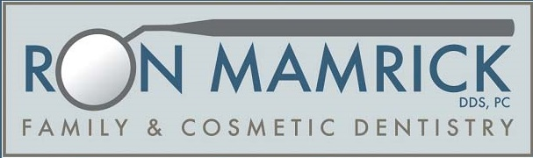

Chemo Care for the Mouth

- Brush with a soft or extra soft toothbrush after every meal.
- Brush with a PRESCRIPTION strength toothpaste, either Prevident or Clinpro.
- Floss after each meal.
- Use a waterpik on low power with warm water. Mix water with ½ tsp salt and baking soda.
- If you vomit, do not immediately brush with toothpaste. Rinsing with baking/soda combination is a better option. This dilutes the acid in your mouth from the vomit. You can brush without toothpaste if you want. You can also apply toothpaste to the tongue or prescription MI paste.
- Rinse your mouth every 2 hours with warm water and baking soda (2 tsp baking soda per quart of water).
- If you get mouth sores contact your medical doctor or me for a prescription mouth rinse.
- Sip on water or suck on ice chips throughout the day.
- Keep Vaseline on lips for lubrication.
- Adequate nutrition is key. Eat soft foods, if you have mouth sore. You can make smoothies to get your nutrition in. There are several good recipes you can find.
- If you get a yeast infection, contact your medical doctor.
- We recommend seeing us every 3 months, that way we can keep a close eye on your oral health.

